CHEM-115 Quiz 7 (Chapter 11) November 10, 2017

Name: ___________________________

- Which component of an amino acid makes it a “chiral” molecule?
- alpha carbon c) carboxylic acid e) R-group
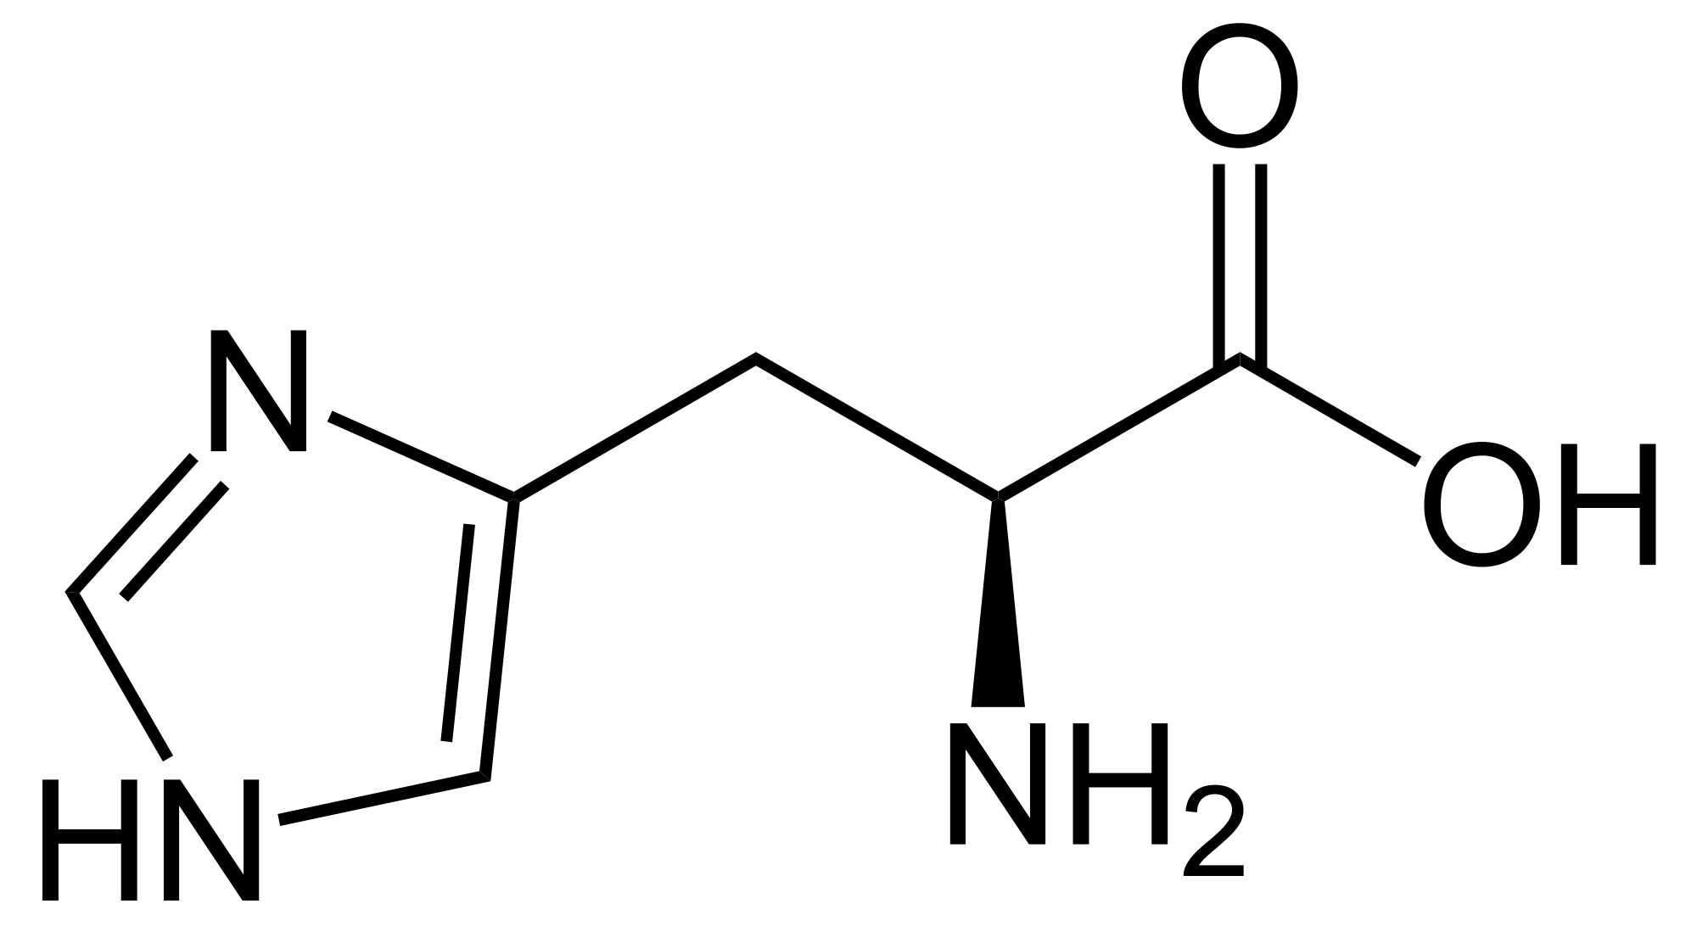
- amine d) hydrogen

- Circle the chiral carbon(s) in the molecule shown to the right:

- The overall charge on acidic amino acids at pH 1 is:
a) 0 b) +1 c) -1 d) +2 e) -2

- The peptide bond formed between two amino acids in a polypeptide is a type of ______ bond.
a) ester b) amide c) amine d) thioester e) ether

- Alpha helicies and beta sheets are examples of what kind of protein structure?
a) primary b) secondary c) tertiary d) quaternary

- Enyzmes are catalytic proteins, which mean they alter the ____________ of a reaction.
- enthalpy change (ΔH) c) activation energy (E_{A}) e) b & d
- rate (or speed) d) a & b f) all of the above

- The intermolecular force that is most responsible for secondary structure folding in proteins is:
a) dispersion forces b) salt bridges c) disulfide bonds d) hydrogen bonds
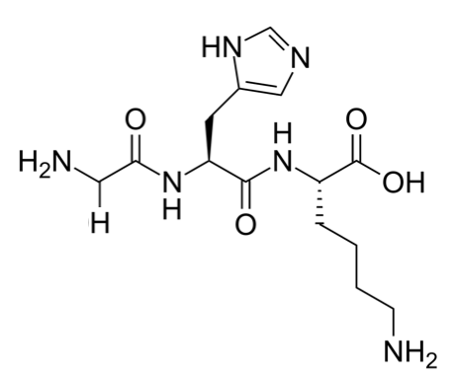
- In the tripeptide shown to the right:
  - Draw rectangles around the peptide bonds
  - Draw circles around the R-groups

CHEM-115 Quiz 7 (Chapter 11) November 10, 2017

Name: _____________________________

- Which component of an amino acid makes it a “chiral” molecule?
- hydrogen c) carboxylic acid e) R-group
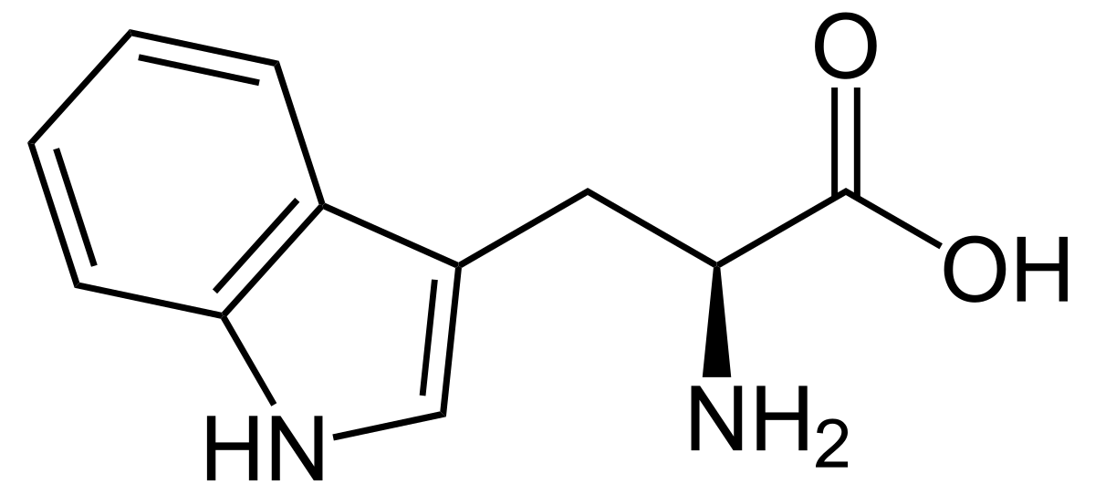
- carboxylic acid d) alpha carbon

- Circle the chiral carbon(s) in the molecule shown to the right:

- The peptide bond formed between two amino acids in a polypeptide is a type of ______ bond.
a) amide b) ester c) ether d) thioester e) alcohol

- Enyzmes are catalytic proteins, which mean they alter the ____________ of a reaction.
- activation energy (E_{A}) c) enthalpy change (ΔH) e) b & d
- rate (or speed) d) a & b f) all of the above

- Which of the following types of tertiary interactions involves acidic amino acids?
a) dispersion forces b) salt bridges c) disulfide bonds d) hydrogen bonds

- The intermolecular force that is most responsible for secondary structure folding in proteins is:
a) dispersion forces b) salt bridges c) disulfide bonds d) hydrogen bonds

- The charge on basic amino acids at pH 1 is:
a) 0 b) +1 c) -1 d) +2 e) -2
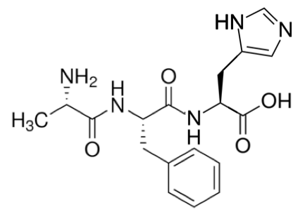
- In the tripeptide shown to the right:
  - Draw rectangles around the peptide bonds
  - Draw circles around the R-groups

